https://www12.statcan.gc.ca/census-recensement/2021/as-sa/fogs-spg/alternative.cfm?dguid=2021A00053518013&lang=e&objectId=5_3&topic=7&utm_source=chatgpt.com
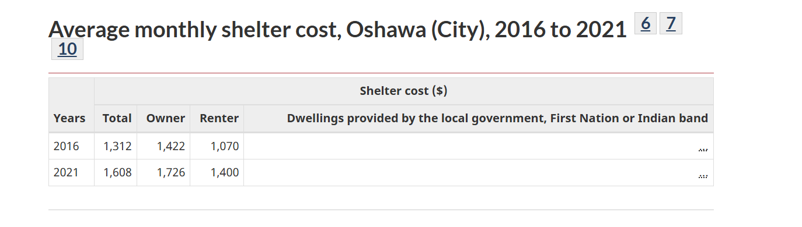
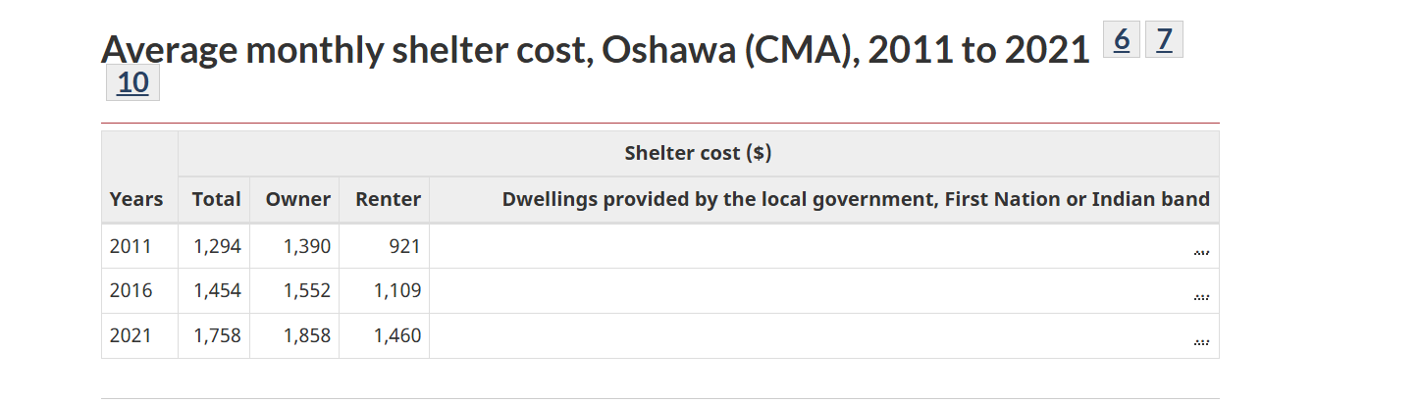
Tuition
747.85
https://registrar.ontariotechu.ca/fees-and-payment/domestic-student-tuition/undergraduate-domestic-tuition1.php

Food
421.45
https://www.durham.ca/en/health-and-wellness/resources/Documents/HealthyLiving/FoodPoverty/Monitoring-Food-Affordability-Durham-Region.pdf

Rent
https://www03.cmhc-schl.gc.ca/hmip-pimh/en/Dashboard/Highlights?geoName=Oshawa&geographyId=1250&t=3

Transit
https://www.durhamregiontransit.com/en/fares-and-passes/u-pass.aspx

Earn:
Assuming it is a part time student that can only work less that 24 hours:
18$ x 24 x 4 x0.86= 1920 x 0.86 = 1486.08

Clothing:
$50-100
https://studentlife.utoronto.ca/task/living-costs-in-toronto/
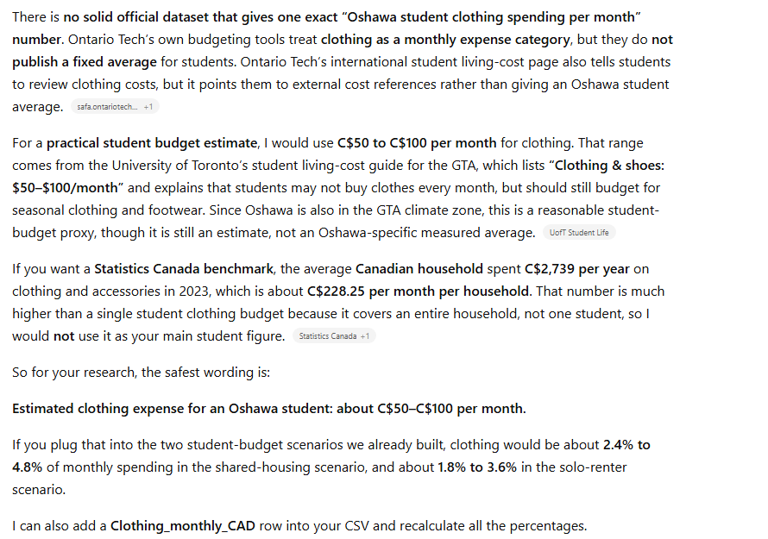

Books & supplies:
https://studentlife.utoronto.ca/task/living-costs-in-toronto/
$550/semester You will likely have additional expenses beyond your tuition related to your courses, such as books, supplies, lab equipment, electronic devices and other technology.

Internet: $60 – $115/month Telecommunications providers often have discounts for students. Make sure to ask!

Phone bill: $50 – $100/month Canadian cell phone plans are notoriously expensive, but there are some affordable mobile service provider options in the GTA.
OSAP:
Assuming in the best scenario, if you are single: you get 525/ week

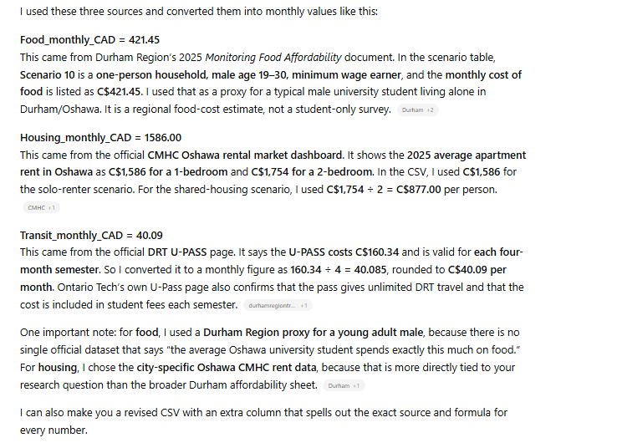
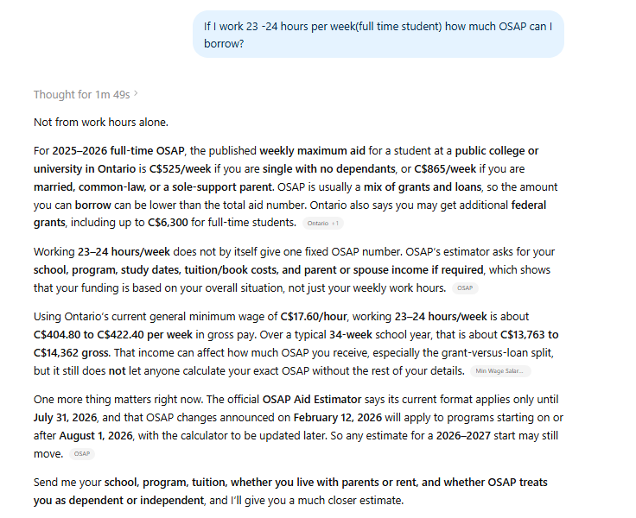

1486.08 Earn - 747.35 Tuition - 421.45 Food -800 Rent -40.09 transport- (550/4)Book - 80 Internet - 60 Phone bil -100 clothing = -375.31$

